1. Define the following: Wave Height, Wave Period, Wave Length, Wave Crest and Wave Trough.

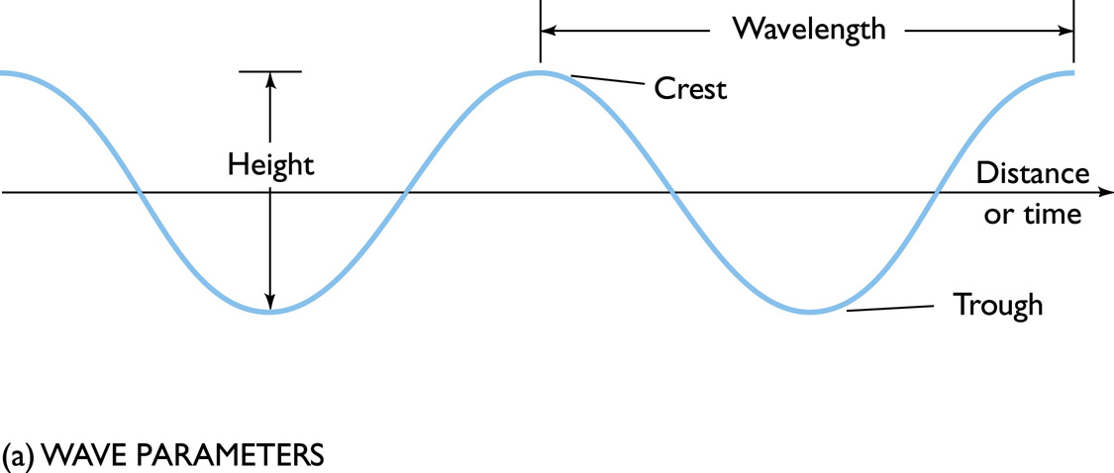

Wave crest – highest part

Wave trough – lowest part

Wave height - overall vertical change in height between the crest and the trough (= 2 x amplitude)

Wave length - Distance between two successive crests

Wave period - time required for two successive crests or two successive troughs to pass a point in space

1. Why is a Tsunami classified as a shallow water wave?

Are shallow water waves because their wavelengths are so long -- deep water waves are found in water deeper than 1/2 their wavelength, but if a tsunami has a wavelength of 200 km, it would need 100 km of depth and the deepest oceans rarely exceed 11 km

1. If an earthquake occurs in the deep ocean at a depth of 4km, at what speed will the Tsunami travel (assume g = 9.8 m/s2)?

c = sqrt(g*d)

= sqrt(4000 * 9.8)

= 197 m/s

= 709.2 km/hr

1. With the aid of a diagram describe the wind regime associated with the Hadley cell. How does it compare to the Polar Cell?

Though cool and dry relative to equatorial air, the air masses at the 60th parallel are still sufficiently warm and moist to undergo convection and drive a thermal loop. At the 60th parallel, the air rises to the tropopause (about 8 km at this latitude) and moves poleward. As it does so, the upper level air mass deviates toward the east. When the air reaches the polar areas, it has cooled and is considerably denser than the underlying air. It descends, creating a cold, dry high-pressure area. At the polar surface level, the mass of air is driven toward the 60th parallel, replacing the air that rose there, and the polar circulation cell is complete. As the air at the surface moves toward the equator, it deviates toward the west. Again, the deviations of the air masses are the result of the Coriolis effect. The air flows at the surface are called the polar easterlies.

The Hadley cell is a global scale tropical atmospheric circulation that features air rising near the equator, flowing poleward at 10–15 kilometers above the surface, descending in the subtropics, and then returning equatorward near the surface. This circulation creates the trade winds, tropical rain-belts and hurricanes, subtropical deserts and the jet streams. Each Hadley cell operates between 0 and 30 degrees north and south and is mainly responsible for the weather in the equatorial regions of the world.

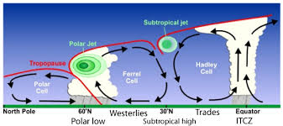

1. Sketch an idealized tidal bulge at Spring Tide. Include the earth, moon and sun. Show the interplay between gravitational and centrifugal forces.

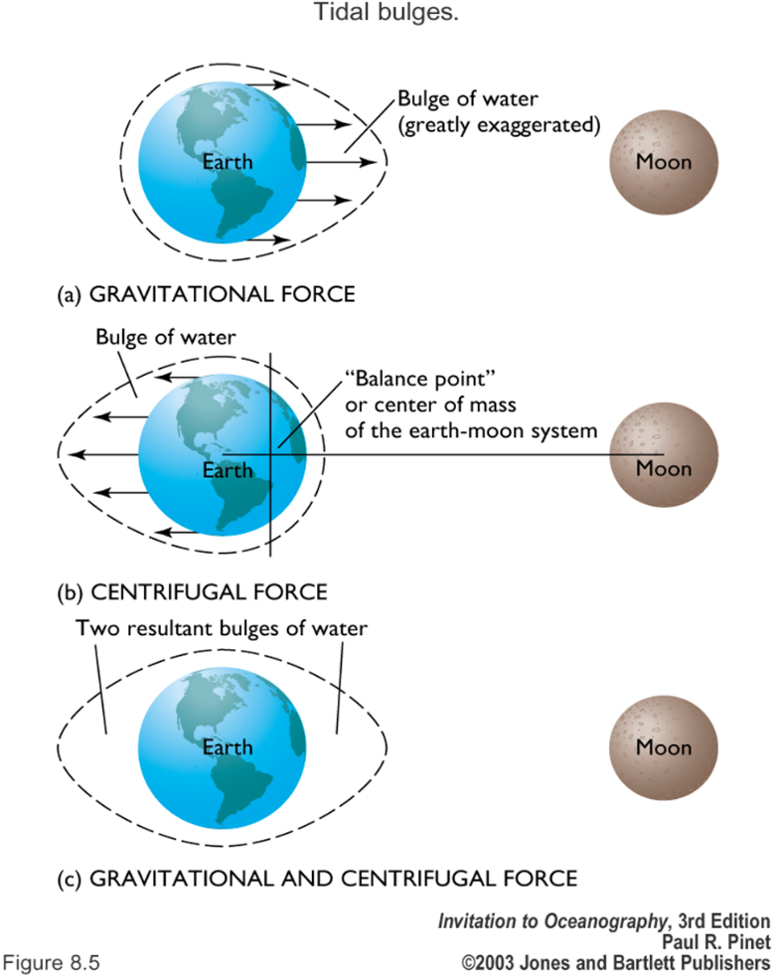

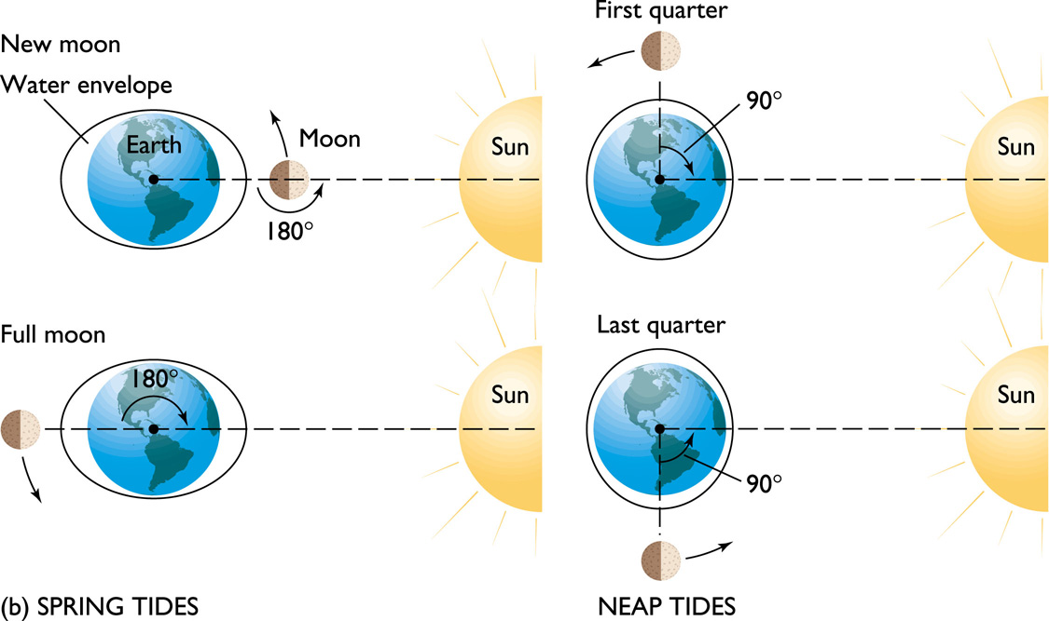

1. How does the pycnocline affect dissolved oxygen concentrations?

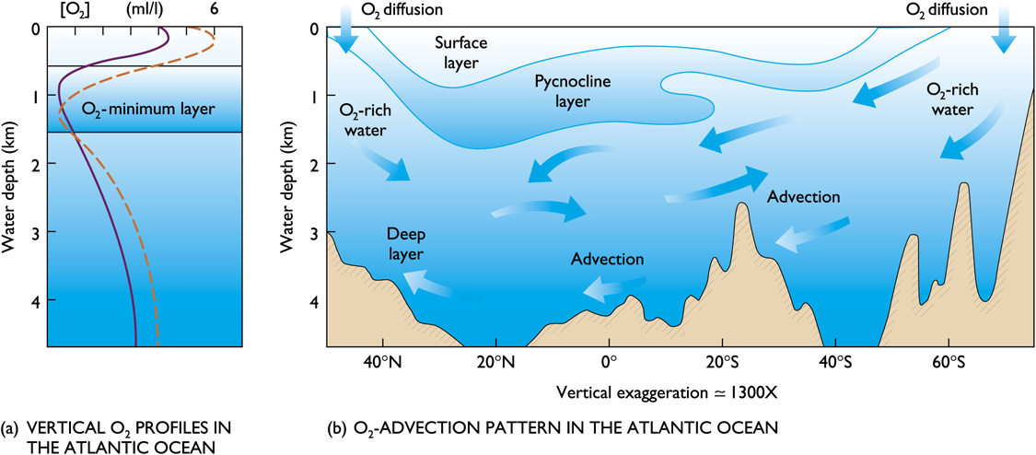

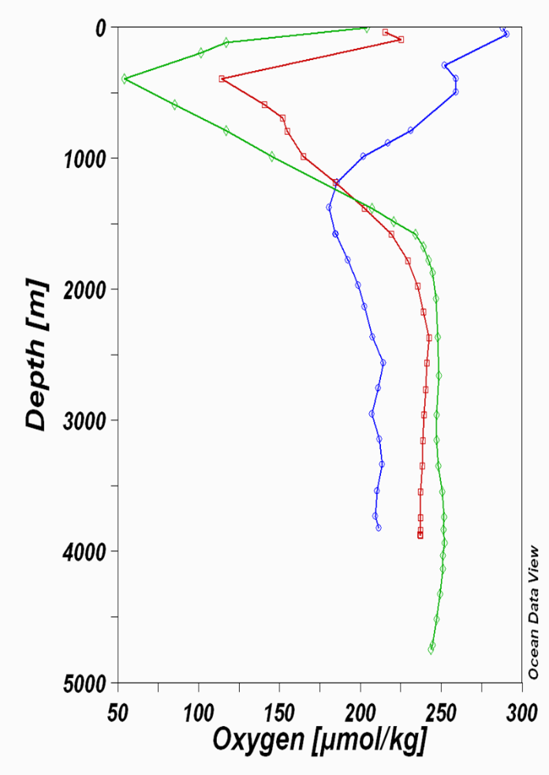Oxygen tends to be abundant in the surface layer and deep layer bottom, but lowest in the pycnocline. Surface layer is rich in oxygen because of photosynthesis and contact with the atmosphere.

Oxygen minimum layer occurs at about 150 to 1500m below the surface and coincides with the pycnocline. Sinking food particles settle into this layer. The food draws large numbers of organisms which respire, consuming oxygen. Decay of uneaten material consumes additional oxygen.

Density difference prevents mixing downward of oxygen-rich water from the surface or upwards from the deep layer.

The deep layer is rich in oxygen because its water is cold and under pressure. Consumption is low because there are fewer organisms and less decay consuming oxygen. Anoxic waters contain no oxygen and are inhabited by anaerobic organisms (bacteria).

1. Explain the sequence of events leading to the formation, expansion, contracting and eventual elimination of ocean basins.

The cyclical opening and closing of ocean basins caused by movement of the Earth's plates. The Wilson cycle begins with a rising plume of magma and the thinning of the overlying crust. As the crust continues to thin due to extensional tectonic forces, an ocean basin forms and sediments accumulate along its margins. Subsequently subduction is initiated on one of the ocean basin's margins and the ocean basin closes up with volcanic activity. When the crust begins to thin again, another cycle begins.

1. Define the term significant wave height for measurements of surface wind waves recorded over a period of 30 minutes (assume that there are 180 individual waves in the record). Define the terms maximum wave height and “rogue” wave height in terms of this significant wave height.

* Significant wave height - the mean wave height (trough to crest) of the highest third of the waves
* Maximum wave height – tallest of all waves from trough to crest. Would be the far right of the spectrum.
* Rogue wave height - large, unexpected and suddenly appearing surface waves caused by both constructive and destructive interference. Would likely be greater than the significant height.

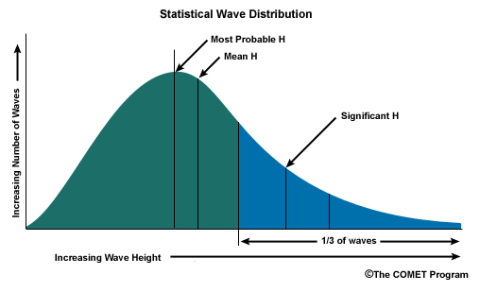

1. List 3 ways in which excess heat absorbed in the tropics is re-distributed to higher latitudes.

The redistribution of energy across the Earth's surface is accomplished primarily through three processes: sensible heat flux, latent heat flux, and surface heat flux into oceans.

* Sensible heat flux - the process where heat energy is transferred from the Earth's surface to the atmosphere by conduction and convection.
* Latent heat flux - moves energy globally when solid and liquid water is converted into vapor. Is the global movement of latent heat energy through circulations of air and water. Atmospheric circulation moves latent heat energy vertically and horizontally to cooler locations where it is condensed as rain or is deposited as snow releasing the heat energy stored within it.
* Surface heat flux - process where heat energy is transferred into land and ocean surfaces on the Earth. Much of this transfer takes place when solar radiation absorbed at the land or ocean surface is converted into heat energy. On land surfaces, surface heat is transfered down into the ground by conduction. Heat energy is transfered to greater depths in ocean surfaces because liquids have the ability mix by convection. Heat energy stored in ocean waters can also move quickly over large horizontal distances in a poleward direction through ocean currents.

1. Give the units of surface heat flux. State how these units relate to those for energy .

joule per second, or watt

where

J = Joule

s = second

W = watt

Joule is a measure of energy and Watt is a measure of energy per unit time.

1. In the English Channel the tidal range is greater on the French side than the English side. Briefly explain why this is the case.

The English Channel is a long and narrow basin. Currents in these basins simply reverse direction between high and low tide, flowing in with the high tide and out with the low tide. Tidal ranges increase if a bay tapers landward because water is funneled towards the basin’s narrow end. This is the case with France along the Normandy coastline. The coastline tapers inward, giving France a larger tidal range.

1. Total primary production by phytoplankton is divided between “new” and “regenerated” production. Differentiate between these two variables in terms of phytoplanktonic nitrogen utilisation.

* New production - supported by nutrient inputs from outside the euphotic zone, especially upwelling of nutrients from deep water, but also from terrestrial and atmosphere sources. Depends on mixing and vertical advective processes associated with the circulation.
* Regenerated production – the recycling of nutrients. When nitrogenous organic molecules are ultimately metabolised by organisms, they are returned to the water column as ammonium (or more complex molecules that are then metabolised to ammonium). This is known as regeneration, since the ammonium can be used by phytoplankton, and again enter the food-web.

**1(a)** The attached oceanographic section depicts the vertical distribution of salinity in the Atlantic Ocean from 60°N to 60°S. Discuss the changes in salinity concentration through the water column from north to south.

Because freshening and salinification occur in different places, salinity at a particular location reflects the upstream source of the water there. In subtropical latitudes, high surface evaporation creates high salinity near the sea surface. In subpolar latitudes, high precipitation creates low salinity near the sea surface. As these waters flow into the ocean interior, they create layers of high and low salinity.

At mid-depth (i.e., around 1000 to 2000 m deep), outflows from the highly evaporative Mediterranean and Red Seas create a vertical salinity maximum in the North Atlantic and Indian Oceans, respectively. Also at mid-depth in the subtropical and tropical regions, the relatively fresh, but dense, surface water from higher latitudes flows in and creates a vertical salinity minimum, most prevalent in the Southern Hemisphere and North Pacific. The North Atlantic is the most saline ocean and the North Pacific the freshest.

**1(b)** What causes these changes in salinity concentrations between the Equatorial, Subtropical and Polar regions?

* precipitation
* evaporation
* ice melting
* water freezing

These processes are mainly facilitated by the postiioning of major atmospheric circulation cells. These cells choose the positioning of high and low pressure areas that are responsible for precipitation and evaporation. The position of latitude also effects the available heat transfer from sun the sea surface, which effects climate.

**1(c)** Why does the Southern Hemisphere component of the section appear to be fresher than the Northern Hemisphere?

The Southern ocean’s upwelling system brings warm less-saline water to the ocean’s surface. When salt is expelled as sea ice forms, the cold salty water sinks creating the Antarctic Bottom Water which flows towards the equator. So the southern hemisphere appears to be less saline because of an underlying thermohaline cycle.

2. Write a popular scientific article about Tsunamis. Include aspects relating to their generation, characteristics in the open ocean and impact on the shoreline. Sketch a public warning sign that would be suitable for placement at a tsunami-prone location.

* harbor wave
* shallow water waves because their wavelengths are so long -- deep water waves are found in water deeper than 1/2 their wavelength, but if a tsunami has a wavelength of 200 km, it would need 100 km of depth and the deepest oceans rarely exceed 11 km
* created as a result of submarine activity (volcanic, subduction, slumping)
* act more like a flooding wave. A twenty foot tsunami is a twenty foot rise in sea level
* extremely long wave length and period
* extrmeely quick moving
* powerful

3. Draw a simple diagram in the vertical-longitude plane that shows the annual mean circulation in the atmosphere. State which of the circulation cells is a direct thermal cell and briefly explain why.

The Hadley and Polar system provides an example of a thermally direct circulation. Both cells have their rising branches over warm temperature zones and sinking braches over the cold temperature zone. Both cells directly convert thermal energy to kinetic energy.

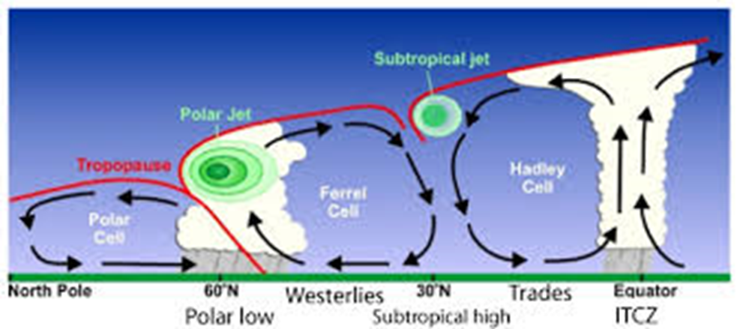

4. Draw a diagram of a section across the equatorial Pacific that depicts the structure of the winds, and the circulation and thermocline in the upper ocean. In a second diagram, illustrate how these features change during an El Nino event .

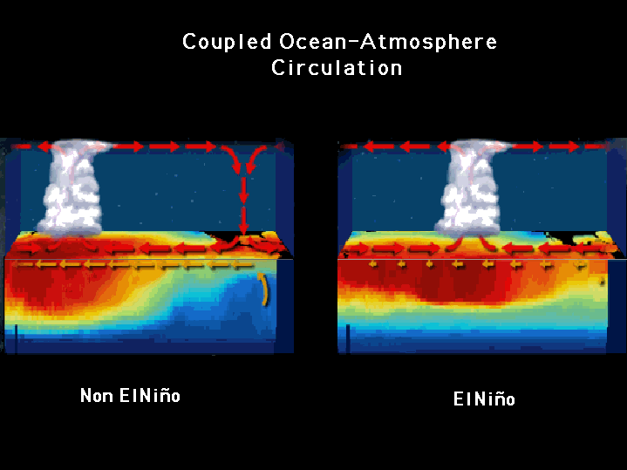

5(a) The volume of the world ocean is approximately 1.3 x 1018 m3.

Earth’s land surface area is 15 x 1013 m2.

Average salt content of ocean water is 35 x 103 g.m-3.

Density of salt = 2.2 x 106 g.m-3. (n.b. density = mass / volume)

If [hypothetically] the world ocean evaporated and all the solid salt in the ocean was spread over the Earth’s land surface, how deep (m) would it be?

Show your calculations.

5(b) Provide a sketch of a Generalized Marine Food Web in a typical coastal water column.

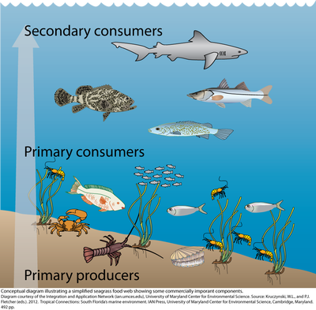

Tertiary Consumers

|

Secondary Consumers

|

Primary Consumers

|

Primary Producers

6(a) Distinguish between the solubility pump and biological pump with respect to carbon in the world ocean.

Solubility pump:

A physico-chemical process that transports carbon (as dissolved inorganic carbon) from the ocean's surface to its interior. The solubility pump is driven by the coincidence of two processes in the ocean.

* The solubility of carbon dioxide is a strong inverse function of seawater temperature (i.e. solubility is greater in cooler water).
* The thermohaline circulation is driven by the formation of deep water at high latitudes where seawater is usually cooler and denser

Since deep water (that is, seawater in the ocean's interior) is formed under the same surface conditions that promote carbon dioxide solubility, it contains a higher concentration of dissolved inorganic carbon than might be expected from average surface concentrations. Consequently, these two processes act together to pump carbon from the atmosphere into the ocean's interior.

Biological pump:

The ocean's biologically driven sequestration of carbon from the atmosphere to deep sea water and sediment. It is the part of the oceanic carbon cycle responsible for the cycling of organic matter formed mainly by phytoplankton during photosynthesis (soft-tissue pump), as well as the cycling of calcium carbonate (CaCO3) formed into shells by certain organisms such as plankton and mollusks (carbonate pump).

Once this carbon is fixed into soft or hard tissue, the organisms either stay in the euphotic zone to be recycled as part of the regenerative nutrient cycle or once they die, continue to the second phase of the biological pump and begin to sink to the ocean floor. The sinking particles will often form aggregates as they sink, greatly increasing the sinking rate. It is this aggregation that gives particles a better chance of escaping predation and decomposition in the water column and eventually make it to the sea floor.

The fixed carbon that is either decomposed by bacteria on the way down or once on the sea floor then enters the final phase of the pump and is remineralized to be used again in primary production. The particles that escape these processes entirely are sequestered in the sediment and may remain there for millions of years. It is this sequestered carbon that is responsible for ultimately lowering atmospheric CO2.

**6(c)** What exactly is causing ocean acidification, and why is the carbonate concentration declining?

Ocean acidification is the ongoing decrease in the pH of the Earth's oceans, caused by the uptake of carbon dioxide (CO2) from the atmosphere. An estimated 30–40% of the carbon dioxide from human activity released into the atmosphere dissolves into oceans, rivers and lakes. Excess carbon dioxide enters the ocean and reacts with water to form carbonic acid, which decreases ocean pH (i.e., makes seawater less basic), and lowers carbonate ion concentrations.